Address B. c college east Satyajit Nagar Asansol-713304
Email chakrabotymitrika9@gmail.com

MITRIKA CHAKRABORTY

Application: Nurse Position
Sir/madam
Hiring Manager,
I am writing to express my keen interest in the entry -level nursing position as a recent graduate with a nursing degree from the West Bengal University of Health Science, I am eager to contribute my skills and passion for patient care to your esteemed healthcare team.

During my academic journey, I completed rigorous coursework, gaining a solid foundation in nursing experience may be limited, my dedication to learning adaptability and strong communication skills make me a well round candidate for this position. I am particularly drawn for commitment to putting patient first and I am excited about the opportunity to contribute to your team.
I am confident that my academic achievement coupled with my passion for patient advocacy make me a valuable candidate for nursing role would welcome the chance to discuss how my skills and enthusiasm align with need of your healthcare facility in more details. Thank you for considering my application.
Sincerely,
Mitrika Chakraborty

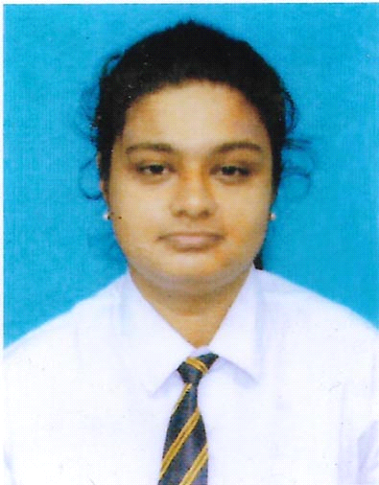  LANGUAGES KNOWN  - English  - Bengali  - Hindi  HOBBIES  - Reading  - Jogging  - Gardening  - Traveling  INTERNSHIP  6 months Intership at Gouri devi institute of medical sciences and hospital  EXPERIENCE  Fresher  CONTACT  Address:- B.C college east Satyajit Nagar Asansol-713304  Phone:- 7001584192  E Mail:- Chakrabortymitrika9@gmail.com  REFERENCES  Available on request. |  | MITRIKA CHAKRABORTY  PROFILE  Passionate and dedicated Nurse. .Bringing forth the ability to thoroughly and accurately assess the health of patients and prescribe the proper treatment programs for optimal health moving forward .Adapt in as a working as a collaborative team member to ensure that patient receive the highest level of care.  PERSONAL INFORMATION  NAME: Mitrika Chakraborty  FATHER’S NAME: Ratan Chakraborty  DOB: 05/02/2002  NATIONALITY: Indian  RELIGION: Hindu  SEX: female  CASTE: General  MARITAL STATUS: single  LANGUAGE KNOWN: English, Bengali , Hindi  EDUCATIONAL QUALIFICATION  EXAMINATION % of marks obtained BOARD  SECONDARY SCHOOL 50.6% CBSC  SENIOR SECONDARY SCHOOL 53.4% CBSC  BSC NURSING 1ST YEAR 56.14% WBUHS  BSC NURSING 2ND YEAR 59% WBUHS  BSC NURSING 3RD YEAR 59.42% WBUHS  BSC NURSNG 4 TH YEAR 57% WBUHS  EXTRA SKILLS  Basic knowledge in computer science, wound care, Recording vitals ,time management Skills ,Patient assessment ,Communication skills ,Patient education

